|  |
| --- |
| COLLEGE OF MANAGEMENT & INFORMATION TECHNOLOGY  **BACHELOR IN INFORMATION TECHNOLOGY**  **Final Year Project**  **Title : Special Occasion System**  **Submitted by:**  Name : Amir Shrestha  Year/ Semester : III Year /V Semester  LCID: LC00017000502  **Date: 14/03/2021** |

**Title : Special Occasion System**

As title itself says everything about my system, This is a web system that gives use feeds about every occasion or event host by any parties who are member of this system. Any party that host events must create a feed or status so that other user can see it.

**Scope :**

A well-defined project scope is a necessity to ensure the success of your project.

So, Why this system?

As there are many events and occasion held in daily basis, we cannot really figure out who, when, where are they hosting an events. Therefore, here comes the use of this system as it provide feeds of instant occasion as well as upcoming occasion.

Problem : Bored, Confuse where to go?

Solution : Special Occasion System

**Aim and Objectives :**

What you hope to achieve at the end of project?

Aim : Make user familiar about numbers of special events helding on the daily basis.

Steps to be taken to achieve desirable outcomes?

Objectives :

* Data sets will be extracted according to account holders,
* Provide feeds of events,
* User frienldy, as all user can use it easily,
* Identify necessary changes that can be made on future,
* End users satisfaction,
* Effective and simplicity,
* Complete project at the given deadline.

**Boundaries of project :**

An individual person, parties can :

1. Create account and its description,
2. Create events,
3. An individual can follow numbers of parties,(here parties can be a person or any other business organization)
4. User gets list of events on their feed page,
5. Events are categorized into four different part :

* Random - feed from random parties on the basis of uploaded date,
* Following - feed from the parties followed by an users,
* Upcomming - Future events,
* Mega Events

1. User can filter feeds (budget, time, following),
2. User can like events,
3. Account holder can upload photo of events,
4. User can get futher detail about event after clicking into event feed,

Advance : Comment on the event.

Note ; Objective and Boundaries can be added as work on project keeps on going.

**ER- Digram :**

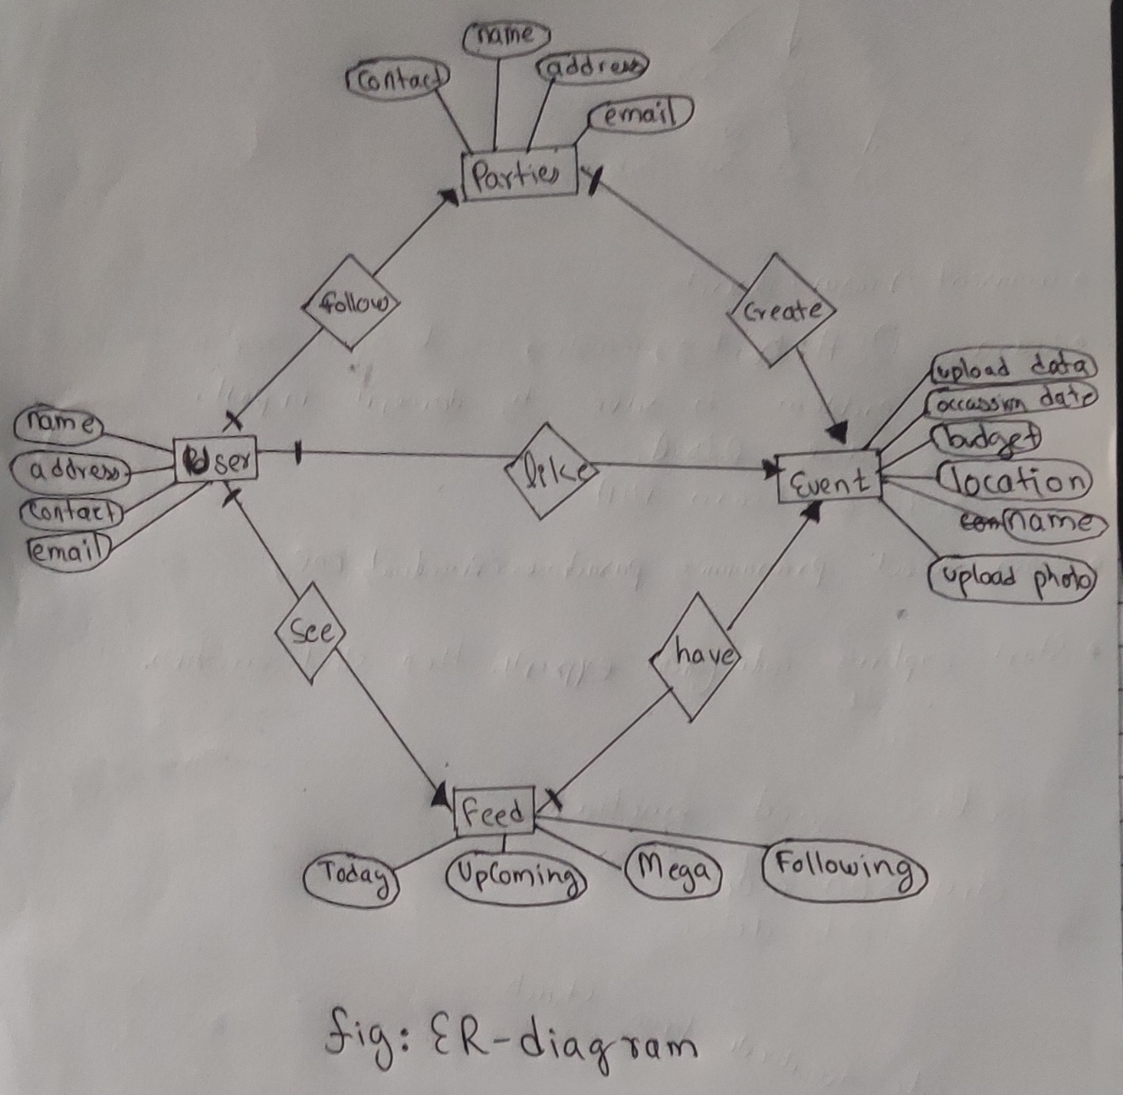

**Inspiration for project :**

Being a hodophile person, I always wanted website like this where I can see every events.

**Conclusion :**

Special Occasion System is a system, that gives use feeds about every occasion or event host by any parties who are member of this system, solving problem for many people who gets confuse during some occasion, gets bored, etc and also solves problem of many business organization regarding customer availability.(Somehow decreases advertisement expenses too)

**Thank You !**